Test Case: tc006_SPX_Dev5_Crear_Requisicion_Spot_Tipo_Cobro_Proyect_Urgent
Step 1 - Enter username and password and click to button Enter: Credentials Entered
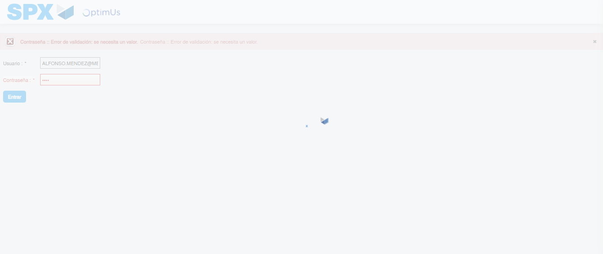Image file-name: QC_Testing-tc006_SPX_Dev5_Crear_Requisicion_Spot_Tipo_Cobro_Proyect_Urgent-1783377286753

Step 2 - Select to UEN and Access to Spot Buy Requisitions : UEN Correctly selected and Correct access
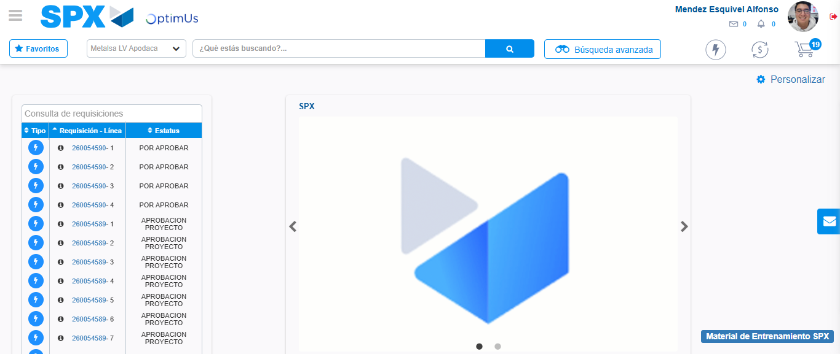Image file-name: QC_Testing-tc006_SPX_Dev5_Crear_Requisicion_Spot_Tipo_Cobro_Proyect_Urgent-1783377311525

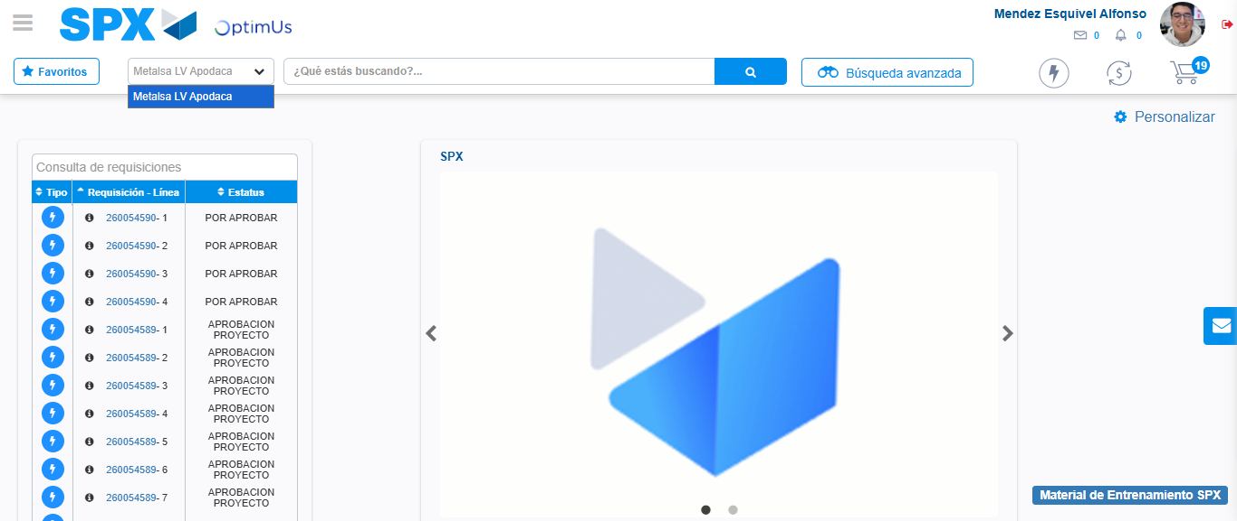Image file-name: QC_Testing-tc006_SPX_Dev5_Crear_Requisicion_Spot_Tipo_Cobro_Proyect_Urgent-1783377313966

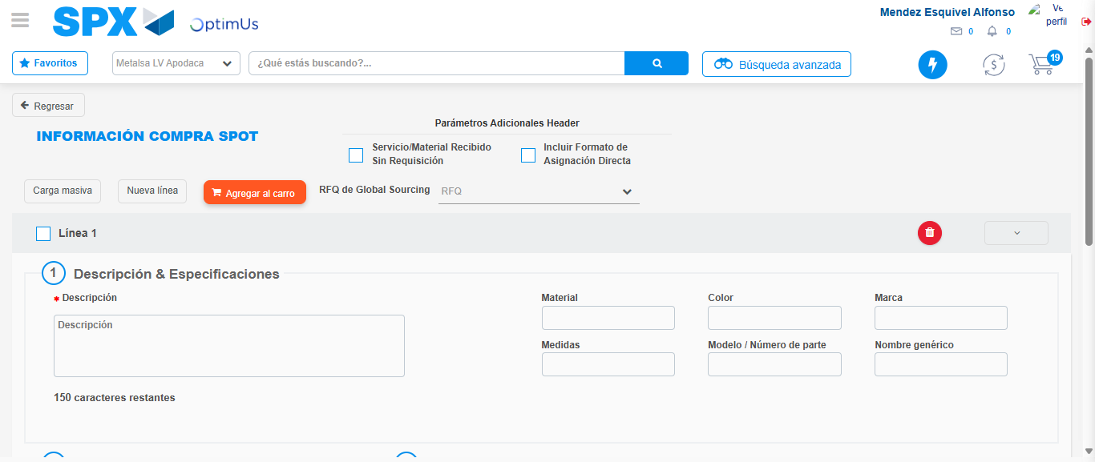Image file-name: QC_Testing-tc006_SPX_Dev5_Crear_Requisicion_Spot_Tipo_Cobro_Proyect_Urgent-1783377336915

Step 3 - Data Capture Spot Buy Requisition: Data captured correctly
Image file-name: QC_Testing-tc006_SPX_Dev5_Crear_Requisicion_Spot_Tipo_Cobro_Proyect_Urgent-1783377337121

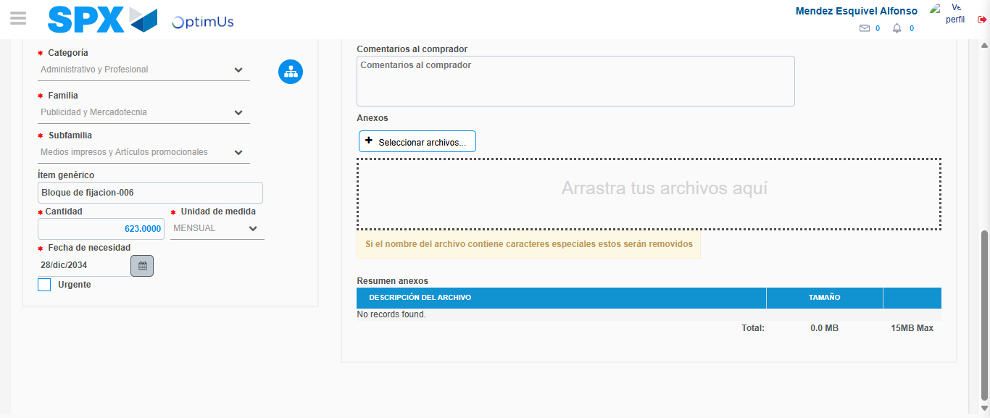Image file-name: QC_Testing-tc006_SPX_Dev5_Crear_Requisicion_Spot_Tipo_Cobro_Proyect_Urgent-1783377347755

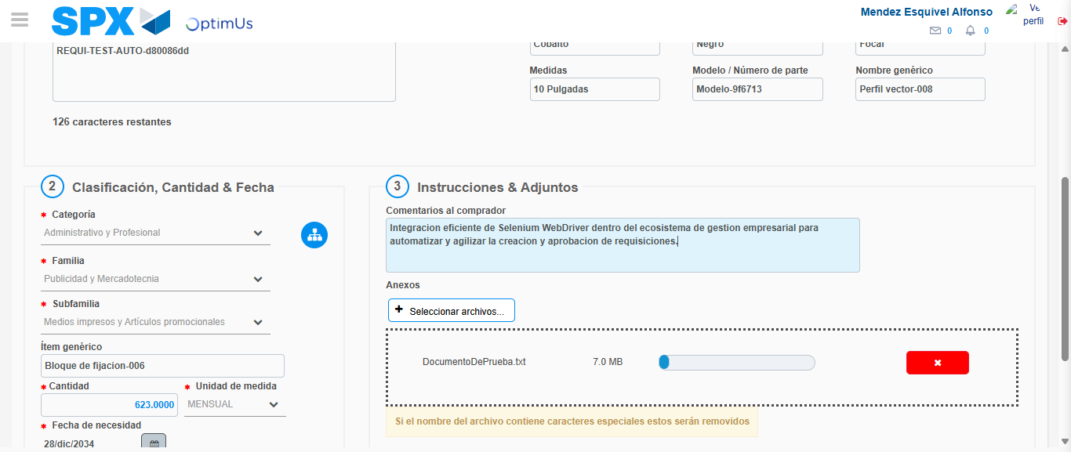Image file-name: QC_Testing-tc006_SPX_Dev5_Crear_Requisicion_Spot_Tipo_Cobro_Proyect_Urgent-1783377348491

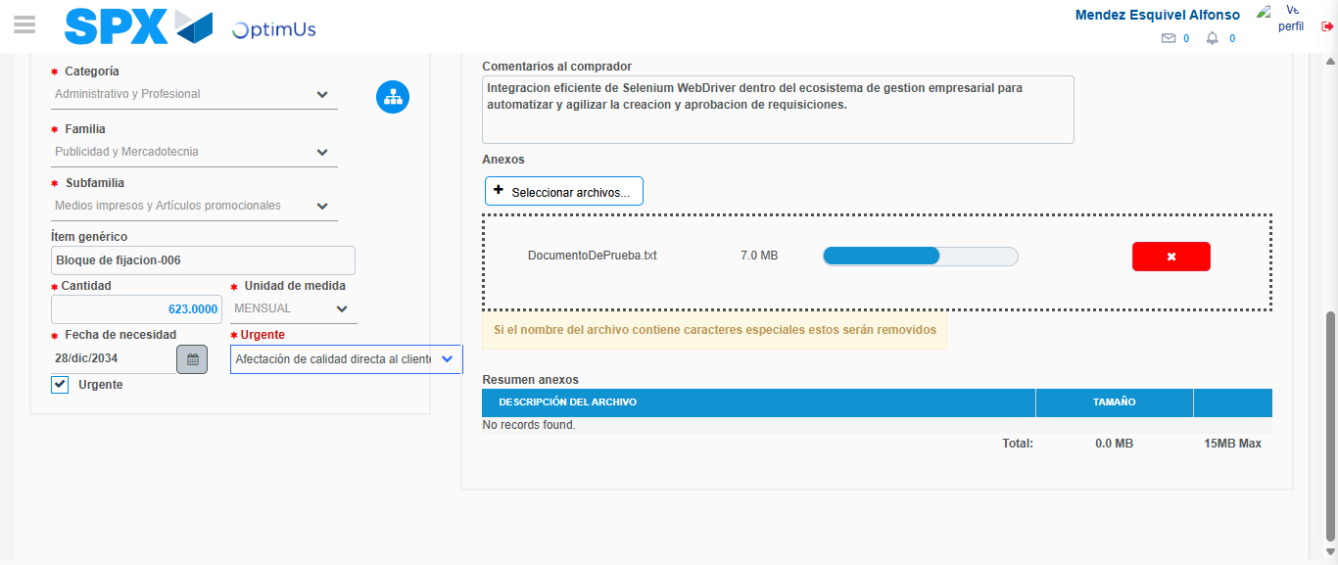Image file-name: QC_Testing-tc006_SPX_Dev5_Crear_Requisicion_Spot_Tipo_Cobro_Proyect_Urgent-1783377352064

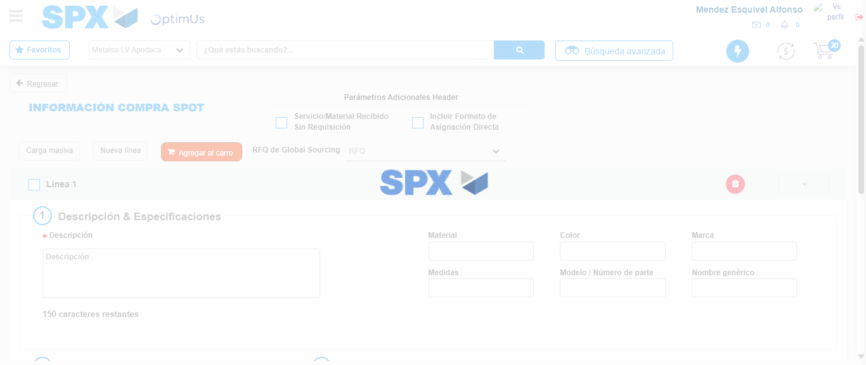Image file-name: QC_Testing-tc006_SPX_Dev5_Crear_Requisicion_Spot_Tipo_Cobro_Proyect_Urgent-1783377359197

Step 7 - Return to Main Page SPX : Return to Main Page SPX
Image file-name: QC_Testing-tc006_SPX_Dev5_Crear_Requisicion_Spot_Tipo_Cobro_Proyect_Urgent-1783377311525

Image file-name: QC_Testing-tc006_SPX_Dev5_Crear_Requisicion_Spot_Tipo_Cobro_Proyect_Urgent-1783377313966

Image file-name: QC_Testing-tc006_SPX_Dev5_Crear_Requisicion_Spot_Tipo_Cobro_Proyect_Urgent-1783377336915

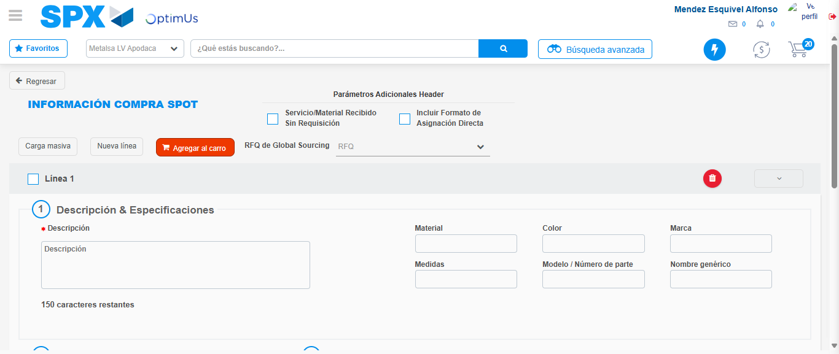Image file-name: QC_Testing-tc006_SPX_Dev5_Crear_Requisicion_Spot_Tipo_Cobro_Proyect_Urgent-1783377361443

Image file-name: QC_Testing-tc006_SPX_Dev5_Crear_Requisicion_Spot_Tipo_Cobro_Proyect_Urgent-1783377361625

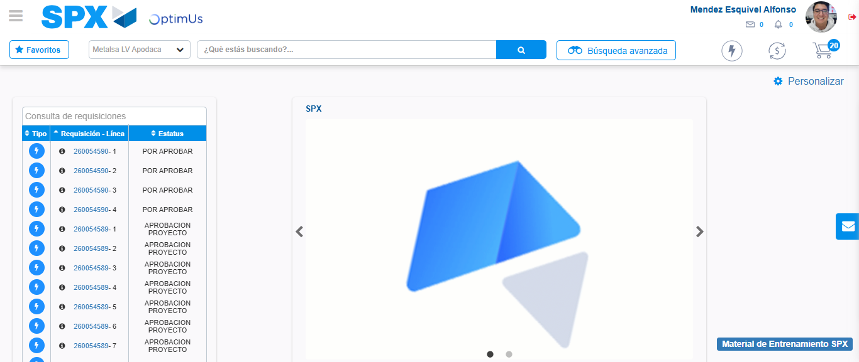Image file-name: QC_Testing-tc006_SPX_Dev5_Crear_Requisicion_Spot_Tipo_Cobro_Proyect_Urgent-1783377382751

Step 8 - Log Out : Log Out SPX
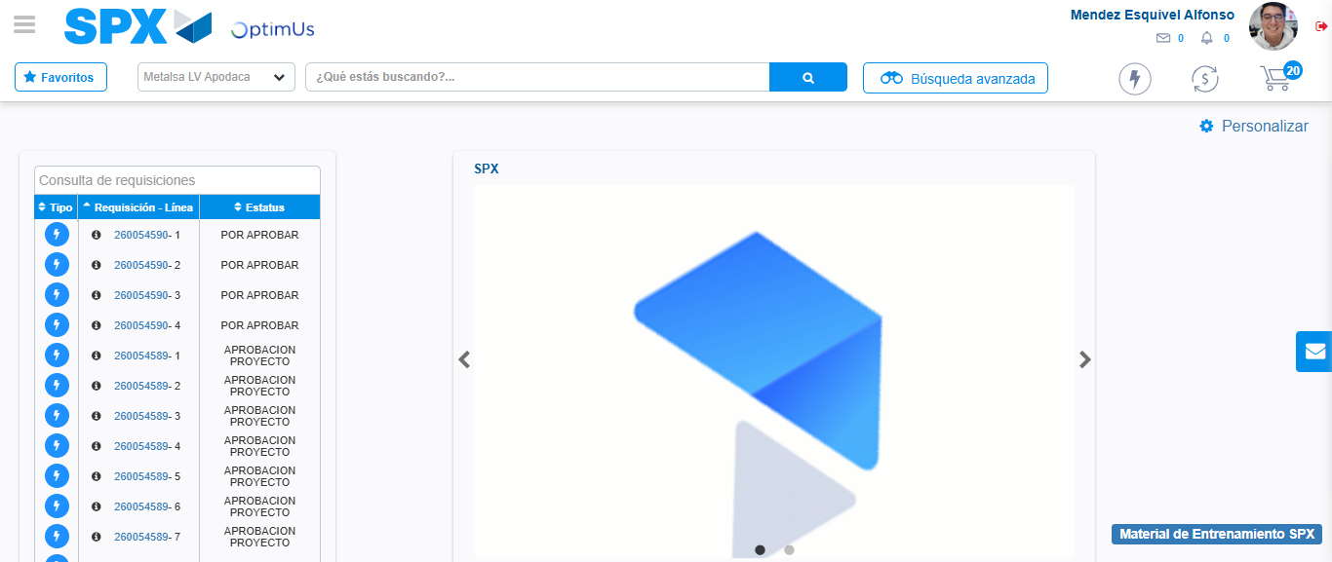Image file-name: QC_Testing-tc006_SPX_Dev5_Crear_Requisicion_Spot_Tipo_Cobro_Proyect_Urgent-1783377383009

